Prompts To Create Unique Camera Angles For AI Videos

Guide by Okaashish

Step 1: Create Initial Reference Image Using Nano Banana Pro

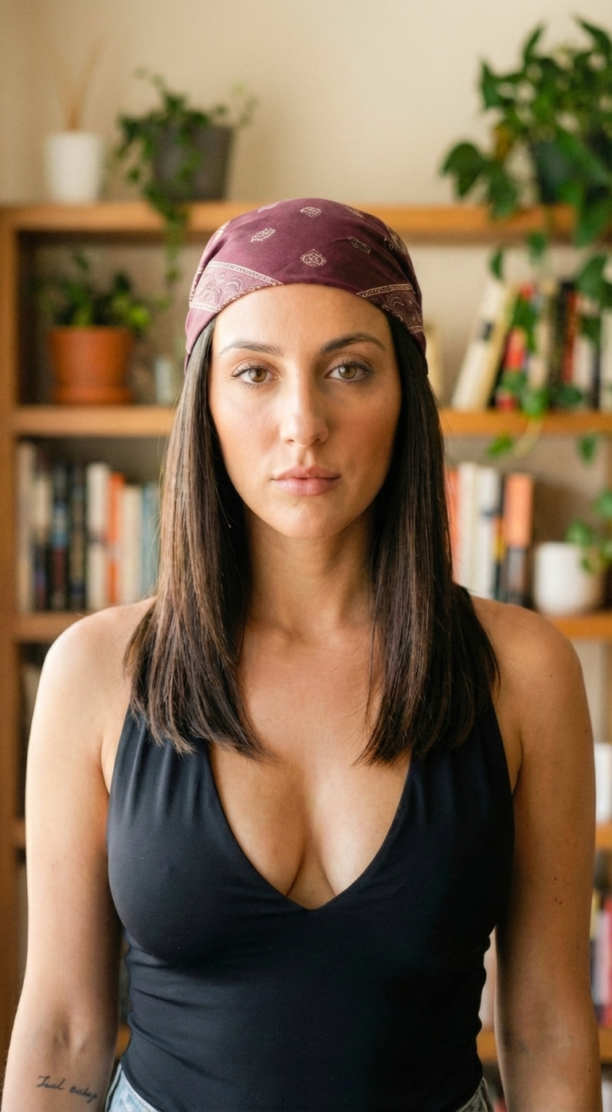
Reference Image Prompt:
Eye-level Medium Close-up Portrait Shot:
Photorealistic editorial portrait of a young woman with light to medium olive skin tone, brown almond-shaped eyes, and dark brown shoulder-length straight hair centre-parted and tucked behind shoulders, minimal natural makeup, and a small cursive tattoo on inner forearm visible. She wears a burgundy-coloured bandana and a black sleeveless V-neck top.
She stands centred in a cozy living room, with shoulders relaxed, facing the camera directly in an upright pose. Shallow depth of field: the subject standing in the foreground in sharp focus. The background features cozy minimal home interior with a wooden bookshelf containing vertically arranged books, potted houseplants, and neutral-coloured walls. A neutral confident expression, a black off-shoulder ribbed dress,
50mm lens, f/2.2 shallow depth of field with high sharpness on subject, softly blurred background, minimal noise. Sharp eyes and realistic skin texture, soft window daylight from the left with gentle shadow falloff, warm neutral colour grade, subtle film grain, natural contrast, and high detail realism.

Step 2: Create Multiple Images With Unique Angles

Follow this:

- Go to Gemini (Here you can access Nano Banana Pro)
- Upload the Reference Image.
- Add Detailed Prompts Given Below & Generate Multiple Angles.

Prompts To Create Multiple Creative Angles:

1. Extreme High-Angle Close Portrait Shot:
Photorealistic editorial-style close portrait of the same subject captured from an extreme high angle, from the front of the model, with the camera looking straight down.
The subject is gazing directly up into the lens with intense eye contact, creating strong vertical perspective compression, a 35mm lens, and an f/1.8 very shallow depth of field.
Same facial features, while hands remain visible, softly blur.
Warm indoor ambient light with soft falloff, natural skin texture and micro detail preserved, muted warm colour grading with subtle contrast, and cinematic realism with fine film grain.

2. Low-angle Portrait Shot:
Create an editorial-style low-angle portrait shot of the same subject.
Camera angle slightly below chest height of the model, camera looking up subtly.
The model's head is slightly tilted down, extending an open hand toward the lens, with an elongated perspective on the fingers.
The subject is looking slightly down directly into the lens with subtle eye contact, with the face and torso softly blurred behind.
35mm lens, f/1.6 shallow depth of field, soft indoor daylight with mild fill, warm beige interior tones, smooth cinematic contrast, clean modern editorial look, natural skin texture and sharp palm lines.

3. High-Angle Overhead Shot:
Photorealistic editorial-style overhead top-down shot of the same subject.
The camera captures the subject from a high angle.
The subject is standing on a grey mat over a wooden floor, looking straight up into the lens while holding a small handheld mic near the mouth.
Strong graphic composition with a centred subject and clean negative space.
35mm lens, f/2.8 moderate shallow depth of field keeping face and shoulders sharp, soft indoor ambient light with mild directional warmth, cinematic editorial styling, warm wood tones, crisp texture detail, minimal noise.

4. Inside The Box POV Shot:
Photorealistic editorial-style POV shot of the same subject from inside a cardboard box.
The camera is placed inside the cardboard box, looking upward through a rectangular opening.
The subject leaning over, peeping inside the box, smiling and reaching in, cardboard edges framing the scene.
24mm lens, f/3.2 moderate depth of field with subject face sharp and box edges slightly softer, bright diffused daylight, clean white background, warm natural colour grade, crisp corrugated cardboard texture, playful product unboxing aesthetic.

5. Inside the Fridge POV Shot:
Photorealistic wide fisheye POV shot of the same subject from inside a refrigerator.
The camera placed inside the refrigerator, looking outward, captures the subject who is standing out at the door.
The subject is leaning in and reaching toward the camera to grab a packaged food item, with a circular vignette framing from the fridge opening.
Shelves and jars in the foreground blur.
10mm fisheye, f/4 deeper depth of field with sharp face and hand, cool fridge LED lighting with cyan cast and clean highlights, high-contrast documentary realism, crisp reflections on plastic and glass, subtle grain, dynamic candid moment.

6. Fisheye Outdoor Close-Up Shot:
Photorealistic ultra-wide fisheye portrait shot of the same subject standing outdoors, viewed through a circular opening, creating a strong round vignette frame.
The subject is leaning in close toward the circular opening and forming an OK hand gesture around the right eye.
A park background with grass and trees curved by lens distortion slightly blurred.
8mm fisheye, an f/5.6 deep depth of field with sharp facial detail and a visible environment, midday sunlight with clear sky reflections, vibrant natural greens and blues, punchy contrast, and a playful experimental photography style.

7. High-Angle Overhead Street Shot:
A cinematic editorial-style high-angle street shot of the same subject walking alone across bold yellow crosswalk stripes. The camera captures the subject from a high-angle overhead viewpoint. The camera looks straight down from a few metres above the ground.
The subject looks straight up towards the camera while crossing the road from the other side of the road. The subject walks towards the camera.
Strong graphic composition and leading lines.
50mm lens, an f/4 moderate depth of field keeping the subject sharp while the background asphalt remains slightly textured, late afternoon hard sunlight casting crisp shadows, a muted urban colour palette with punchy yellow, a subtle film look with fine grain, and a documentary fashion editorial style.

8. Over-the-Shoulder Conversation Shot:
Photorealistic over-the-shoulder shot of the same subject having a conversation with a man.
The camera captures the subject from behind the shoulders of a man whose head & one shoulder are partially visible.
The man placed in the blurred foreground is looking toward the subject seated across a coffee table with books and a mug.
The subject in sharp focus is seated towards the camera, making eye contact with the man and conversing.
50mm lens, f/2 shallow depth of field separating subject from
foreground and background, soft window light from the right, warm cozy grading, documentary lifestyle storytelling, natural skin tones, subtle film grain.

9. Chest-Level POV Shot:
Photorealistic first-person chest-level POV shot of the same subject lifting a cute, fluffy golden retriever puppy toward the lens with both hands.
The subject wears a sleeveless, deep v-neck black top.
The camera, from the subject's chest-level POV, is looking forward at the lifting of the golden retriever puppy. The puppy is centred with relaxed paws and tail visible.
Living room setting with armchair, bookshelf, and plant in soft background blur.
35mm lens, f/1.8 very shallow depth of field with sharp focus on puppy face and fur detail, warm natural window light, creamy highlights, soft shadows, warm beige and wood tones, candid lifestyle photography vibe, subtle filmic grain.
Step 3: Animate These Images Using Kling 2.6

Follow this:

- Go to Freepik & access the AI video generator.
- Upload the first frame, add the below-given prompts & animate the images.
- Tip: Use Kling 2.6 for videos with dialogues & use Kling 2.5 for videos without audio.

Dialogue Video Prompts:

1st Dialogue Prompt: Dynamic FPV Tracking Shot
Visual: A cinematic FPV shot of a young, lively woman wearing a burgundy-coloured bandana and a sleeveless black deep v-neck top.
Her smile radiating curiosity and excitement but soon turns into wild frustration.
She leans into the cardboard box, looks straight into the camera, and maintains eye contact throughout.
The camera swoops in, capturing her fingers pointing towards the camera.
Then she confidently says the dialogue:
"Your AI videos look fake." [pause]
"Because you keep using the same boring angles."
She points at her face with both her hands while saying the dialogue.
The camera maintains sharp focus on the model's face and upper body throughout.

2nd Dialogue Prompt: Cinematic Slow Tracking Shot
Visual: A smooth cinematic tracking shot of a young woman wearing a burgundy bandana and a black sleeveless deep v-neck top.
She is standing in the centre of a cozy living room which is softly lit with natural window light. The bookshelf and plants in the background are blurred.
The camera holds a clean, cinematic mid-shot on her face and upper body. Then the camera begins to glide smoothly backward on a stabilised dolly. It stays perfectly centred and maintains a constant distance from the model.
As she starts walking slowly forward toward the lens in a straight line, she keeps steady eye contact with the camera. Her facial expressions are realistic, calm, and engaging. She makes very minimal, controlled hand and shoulder movements that make her walk look elegant, confident, and bold. While walking, she confidently says the dialogue: "Here are 7 prompts for camera angles, so you can easily upgrade your game." timing the line comfortably across the duration of the walk without rushing.
There are no turns, no reframing, and no cuts. Just a continuous, straight tracking shot. The lighting stays soft and bright on the subject's face with realistic soft shadows. The subject remains locked in crisp focus with a shallow depth of field and subtle motion blur.
3rd Dialogue Prompt: High-Angle Still Shot
Visual: A cinematic high-angle still shot of a young woman wearing a burgundy bandana and a black sleeveless deep v-neck top. She is looking straight up into the camera while holding a small handheld mic near her mouth. She is standing on a soft grey mat, over a wooden floor which is softly blurred in the background.
Camera: The camera holds a steady, cinematic high-angle shot on her face, full upper body and the small wireless mic. The camera is locked off directly above the model’s head in a perfectly vertical, bird’s-eye high-angle shot.
35mm lens, f/2.8 moderate shallow depth of field, keeping face, mic and upper body in sharp focus.
Action: While holding a small wireless mic in her right hand close to her mouth, she keeps that hand steady with only minimal, controlled adjustments.
While looking up towards the camera with steady eye contact, the model confidently says this dialogue: "Be ready to screenshot and save this post for later." timing the line comfortably across the duration without rushing.
Her shoulders and torso remain mostly still, with only slight, elegant movements as she speaks. While saying the final phrase "save this post for later" she slowly raises her left hand from beside her body. She extends her index finger upward, pointing directly toward the camera above, as if pointing at the viewer’s screen. She holds the pointing gesture, emphasising the ending phrases of the dialogue, gazing at the camera.
There is no camera movement, no panning, and no cuts. Just a stable bird’s-eye high-angle still shot. Warm, soft indoor ambient light with mild directional warmth, cinematic editorial styling, and warm wood tones. Crisp texture detail, minimal noise.

Normal Video Prompts:

1. Cinematic High-Angle Tracking Shot:
A slow high-angle tracking shot of a confident woman wearing a burgundy bandana, a black sleeveless deep v-neck top, and light blue denim strides across a vibrant yellow crosswalk.
Her silhouette casting a long shadow on the asphalt.
The camera follows her from a high angle as she crosses the road in slow motion with bold and elegant body language.
The bright sunlight striking on the model creates a striking visual contrast and focuses on the subject, enhancing the energetic atmosphere.
4K cinematic detail. Very minimal noise or distraction. Only the model is in frame with sharp focus locked on her. No random camera movements, no zoom, no cuts. No other subjects.

2. Cinematic Over-the-Shoulder Conversation Shot:
A cinematic intimate over-the-shoulder shot of a lively woman wearing a burgundy bandana, a black sleeveless deep v-neck top, and light blue denim.
Her eyes sparkling with curiosity as she engages in a deep conversation with a man.
The camera captures the woman from behind the shoulders of a man whose head & one shoulder are partially visible.
The man placed in the blurred foreground is looking toward the woman seated across a coffee table with books and a mug.
Warm sunlight filtering through the window, lush plants and a sofa blurred in the background enhance the cozy living room atmosphere and create a striking visual contrast.
Shallow depth of field. The subject is in sharp focus and seated towards the camera, making eye contact with the man and conversing. She makes minimal, controlled hand and head movements during conversation.
No random camera movements, no zoom, no panning, no cuts. Just a handheld over-the-shoulder conversation shot with sharp focus on the woman.

3. Fisheye POV Shot:
A cinematic fisheye POV shot of a woman wearing a burgundy bandana and a black sleeveless deep v-neck top, from inside a refrigerator.
The woman slowly reaches in and pulls out a plastic food container, the cold air subtly misting.
10mm fisheye, f/4 deeper depth of field with sharp focus on the subject's face and hand.
Subtle handheld camera shake. The camera captures her curious expression under the cool fridge LED lighting. She makes constant eye contact with the camera.
Slow, smooth cinematic motion, 4K quality. High-contrast documentary realism, crisp reflections on plastic and glass, subtle grain, and dynamic candid moments.

4. Fisheye Outdoor Close-Up Shot:
Photorealistic ultra-wide fisheye portrait shot of a woman wearing a burgundy bandana and a black sleeveless deep v-neck top, standing outdoors and looking through a circular peephole.
The camera captures her through a circular peephole, creating a strong round vignette frame.
The peephole is fixed and doesn't move.
The subject is leaning in close toward the circular opening and forming an OK hand gesture around the right eye, giving a playful and curious expression.
She makes very minimal and controlled head movements while peeping.
A park background with grass and trees curved by lens distortion and afternoon natural light flares at the top of the frame, slightly blurred.
8mm fisheye, an f/5.6 deep depth of field with sharp facial detail and a visible environment, punchy contrast, crisp detail, rich colours, smooth motion, and 4K quality.

5. Chest-Level POV Shot:
Photorealistic first-person chest-level POV shot of a cute, fluffy golden retriever puppy held by a woman with both hands.
The puppy is centred with relaxed paws and tail visible and is looking toward the camera. The puppy makes very subtle eye blinks, tail wags, dangles paws, and minimal neck movements.
The camera, from the subject's chest-level POV, is looking forward and tracking the golden retriever puppy held by the woman.
The camera pans to the right very slowly, tracking the puppy as the woman slowly turns around holding the puppy.
35mm lens, f/1.8 very shallow depth of field with sharp focus on puppy face and fur detail, warm natural window light, creamy highlights, soft shadows.
Warm morning light streams through the window. Living room setting with armchair, bookshelf, and plant in soft background blur with subtle film grain.

6. Low-angle Portrait Shot:
Editorial-style low-angle portrait shot of the woman wearing a burgundy bandana and a black sleeveless deep v-neck top. She slowly extends her open hand toward the camera, with an elongated perspective on the fingers.
The camera captures the woman's hand from an angle slightly below chest height of the model. Shallow depth of field: the camera keeps the woman's palm in sharp focus, while her face stays softly blurred in the background.
As the model slowly moves her hand down and slightly tilts her head down, the camera also tilts down slowly, tracking her hand.
She maintains constant eye contact with the camera throughout.
35mm lens, f/1.6 shallow depth of field, soft indoor daylight with mild fill, warm beige interior tones, smooth cinematic contrast, clean modern editorial look, natural skin texture and sharp palm lines. 4K quality.
All Set!

You now have studio-level creative angles for your AI videos. You can create complete AI stories or ad campaigns for brands using this simple workflow.

If you want to keep updated with all the latest AI news and useful tips, join 100k+ subscribers reading our 'FREE' newsletter [Feedough Newsletter by Okaashish]

If you want more such helpful guides, follow Okaashish

